***Keash/Culfadda Newsletter August 18th 2024***

***Twentieth Sunday in Ordinary timeYear B***

**Phone: Fr. Gabriel Murphy (086)3429686**

**Notices for Newsletter email:** [**gmurphy@achonrydiocese.org**](mailto:gmurphy@achonrydiocese.org)

**Masses from Keash & Culfadda Churches are Live streamed.**

**For more information visit our Website:** [**www.keashparish.ie**](http://www.keashparish.ie)

***Please note that the Webcam will be in operation in the Sanctuary area and it’s surrounds of both Churches within our parish.***

**St Kevin’s Church Keash**

**Saturday 17th 6.30pm**  James & Mary Morrisroe, Templevanny.

**Saturday 24th 6.30pm** Frank & Mary Higgins, Derrygola.

**Our Lady of the Rosary Church Culfadda**

**Sunday 18th 10.00am** Papie & Annie Kate Higgins, Townaghmore. Also,

Thomas Redican, Townaghmore.

**Sunday 25th 10.00am** Bianne & Marty Clarke and the deceased members of the Clarke,

Tansey and Cawley families of Carrowreagh.

**Readers.**

**Saturday 17th** Geraldine Hannon. **Sunday 18th** Sharon Hunt.

**Saturday 24th** Breda Forkin. **Sunday 25th** William Henry.

**Priests of the parish Cluster Areas.**

The Priests available in the Parish Cluster Areas are Fr Michael Reilly 071-9183232, Fr James McDonagh 071-9191790, Fr Joseph Caulfield 071-9182551.

**Knock National Novena 2024 – continues :** The National Novena to Our Lady of Knock continues to Thursday 22nd August. Daily ceremonies take place at 3pm and 8pm. Workshops take place at 12.45pm each day. The theme for this year's Novena is 'God Whispering'....How Do You Pray?'

**Knock National Novena - Guest Speakers 2024**

**'Praying the Mysteries of Creation' - Bishop Kevin Doran: Sunday 18th August at 3pm**

Bishop Kevin Doran is Bishop of Elphin and Apostolic Administrator of Achonry. He serves as Chairperson of the Council for Life of the Irish Catholic Bishops’ Conference. He is also Chair of the Committee for Theology and a member of the Council for Justice and Peace and the Council for Doctrine. He represents the Irish Catholic Bishops’ Conference at the Anscombe Bioethics Centre (Oxford) and is the liaison between the Irish Catholic Bishops’ Conference and Irish pro-life groups.

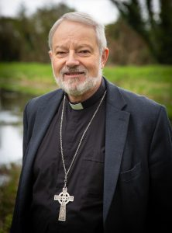

**'Pilgrimage - A Walk With God' - Judith King: Sunday 18th August at 8pm**

Judith King, a native of Donegal now living in County Wicklow, has deepened her interest in pilgrimage in recent years with further research and study.  This study builds on years of interest in theology as well as years of professional work with Religious Congregations, Religious Justice Ministries, Diocesan Clergy and Leadership Teams in all these domains, in Ireland and abroad, who all seek to find new ways of bringing the life-giving invitation and messages of the Gospel to a radically changed culture.  Somehow in the midst of all the profound changes, as people choose more secular ways of celebrating and living life, including their spiritual lives, pilgrimage still endures.  This enduring quality of pilgrimage, not to mention its many unexpected gifts, Judith believes, deserves our special attention.

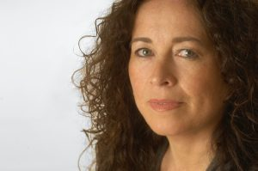

**'Everything Starts From A Prayer' - Sr Orla Treacy: Monday 19th August at 3pm & 8pm**

Sr Orla Treacy is a Loreto Sister from Bray, Co. Wicklow. After living and working in various parts of Ireland, Orla volunteered in 2006 to join a new mission in Rumbek, South Sudan. Today, Orla is the Director of a girls boarding secondary school, a primary school for boys and girls, and a child centre clinic.  Orla studied at Mater Dei Institute of Education, furthered her education with a Master’s from DCU and Manchester University, and holds a Doctorate in the field of Missiology. She has received numerous awards, including the Distinguished Service Award for Irish Abroad.

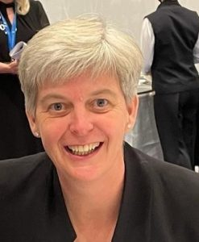

**'With Due Respect' - Fr Michael Mc Cullagh CM: Tuesday 20th August at 3pm and 8pm**

Fr Michael McCullagh CM is a priest of the Congregation of the Mission (Vincentians). His ministries have included teaching, prison ministry, parish ministry, ministry with the Traveller community and spiritual direction in Britain, USA and Ethiopia and in St. Patrick’s College, Maynooth. He is currently based at Knock Shrine with his Vincentian colleague, Fr. Aidan Galvin, CM. They provide ‘A Listening Heart Ministry’ – a support ministry to priests programme. He is the author of ‘With Due Respect – Taking A Second Look At God, At Self, At Others’.

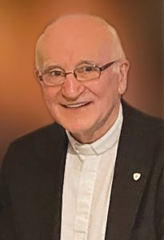

**'Prayer: Discovering the extraordinary in the ordinary Dr Gráinne Doherty: Wed 21st August at 3pm**

Dr Gráinne Doherty works in pastoral ministry, retreat leadership, adult faith formation, and facilitation. Prior to becoming self-employed, Gráinne was part of the Theology department in All Hallows College (Dublin) for many years, while also working in pastoral leadership at both parish and diocesan level. Her Veritas publication “*Joy of Love: A Family Perspective”* (2018) is a book of spiritual reflections and prayers which situates the writings of Pope Francis in the reality of family experience today.

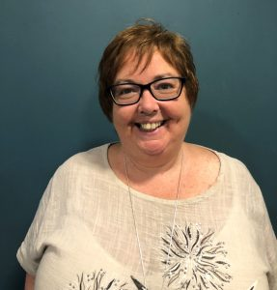

**'Prayer Is Where The Impossible Happens' - Fr Richard Gibbons: Wednesday 21st August at 8pm**

Fr Richard Gibbons  has ministered as Parish Priest and Rector of Knock Shrine since 2012. Fr. Richard will lead this special celebratory Mass on the evening of the 145th anniversary of the Knock Apparition.

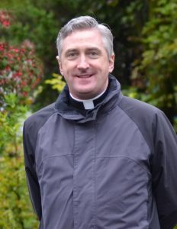

**'Why Is God So Silent?' - Fr Jos Moons sj : Thursday 22nd August at 3pm and 8pm**

Jos Moons  is a Jesuit priest who works as a lecturer at KU Leuven (Belgium). After he focused in his doctoral work on the Second Vatican Council’s view of the Holy Spirit, he now explores how to build up a more inclusive and participatory, synodal Church. Besides his academic work, he trains people in spiritual direction. He published amongst others, “The Art of Spiritual Direction: A Guide to Ignatian Practice” and a much-read article “A Comprehensive Introduction to Synodality: Reconfiguring Ecclesiology and Ecclesial practice.

