***Keash/Culfadda Newsletter August 11th 2024***

***Nineteenth Sunday in Ordinary time***

***Year B***

**Phone: Fr. Gabriel Murphy (086)3429686**

**Notices for Newsletter email:** [**gmurphy@achonrydiocese.org**](mailto:gmurphy@achonrydiocese.org)

**Masses from Keash & Culfadda Churches are Live streamed.**

**For more information visit our Website:** [**www.keashparish.ie**](http://www.keashparish.ie)

***Please note that the Webcam will be in operation in the Sanctuary area and it’s surrounds of both Churches within our parish.***

**St Kevin’s Church Keash**

**Saturday 10th 6.30pm** Niall Michael Soden, Templevanny (2nd Anniversary).

**Saturday 17th 6.30pm**  James & Mary Morrisroe, Templevanny.

**Our Lady of the Rosary Church Culfadda**

**Sunday 11th 10.00am** Catherine Chambers, Killined (2nd Anniversary).

**Feast of the Assumption of the Blessed Virgin Mary.**

**Thursday 15th 10.00am** Pat & Paul Judge, also Josephine & Sharon, Battlefield &

Tubbercurry.

**Sunday 18th 10.00am** Papie & Annie Kate Higgins, Townaghmore. Also,

Thomas Redican, Townaghmore.

**Readers.**

**Saturday 10th** Padraic Duffy. **Sunday 11th** Kieran Kielty.

**Saturday 17th** Geraldine Hannon. **Sunday 18th** Sharon Hunt.

**Priests of the parish Cluster Areas.**

The Priests available in the Parish Cluster Areas are Fr Michael Reilly 071-9183232, Fr James McDonagh 071-9191790, Fr Joseph Caulfield 071-9182551.

**Knock National Novena 2024:**

**Theme ‘Whispering with God’….How Do You Pray?**

The National Novena to Our Lady of Knock takes place from Wednesday 14th to Thursday 22nd August.

Daily ceremonies take place at 3pm and 8pm. Workshops take place at 12.45pm each day.

The theme for this year's Novena is 'God Whispering'....How Do You Pray?'

**Knock National Novena - Guest Speakers 2024**

**'Hope for a changing Church' - Dr. Austen Ivereigh: Wednesday14th August at 3pm & 8pm**

Dr Austen Ivereigh is a British writer and journalist known for his two biographies of Pope Francis, as well as *Let Us Dream*(2020), a bestselling book written in collaboration with him. His most recent book, published this year, is *First Belong to God: On Retreat with Pope Francis* (Messenger), an eight-day Ignatian retreat drawn from the Pope’s writings and talks as a spiritual director. He is Fellow in Contemporary Church History at the Jesuit-run Campion Hall, University of Oxford, and a theological expert at the assemblies in Rome of the current synod.

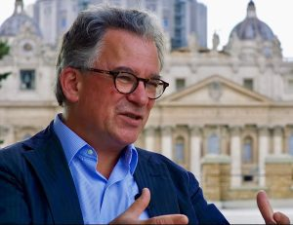

**'Keeping Mary Close' - Fr Richard Leonard sj : Thursday 15th August at 3pm & 8pm**

Fr Richard Leonard is a Jesuit priest. Fr Richard did graduate studies at the London Film School and has a PhD from the University of Melbourne. He directed the Australian Catholic Office for Film & Broadcasting for 22 years. Dr Leonard is an Honorary Fellow of the Australian Catholic University and has been a visiting scholar within the School of Theatre, Film & Television at UCLA and a Visiting Professor at the Pontifical Gregorian University in Rome.  He has lectured on faith and culture all over the world. His latest book, *Why God? Stories to Inspire Faith* has just been released.

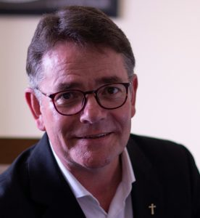

**'Mission Possible' - Toni Pyke: Friday 16th August at 3pm & 8pm**

Toni Pyke PhD is the Justice, Peace and Ecology co-ordinator with the Association of Leaders of Missionary and Religious of Ireland (AMRI). She has worked at the Archdiocese of Boston and the US Catholic Bishops Conference in Washington DC in the Office of the Pastoral Care of Migrants and Refugees. She has lived and worked on issues of international development and development education in Nigeria, South Africa, Uganda, Zambia and Ireland. She has lectured at Maynooth University and the University of South Africa.

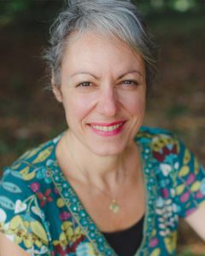

**'Mary, Model of Eucharistic Prayer' - Monsignor Kevin Gillespie: Saturday 17th August at 3pm**

Monsignor Kevin Gillespie serves as Diocesan Administrator of the diocese of Raphoe, which is awaiting the appointment of a new Bishop. A native of Gaoth Dobhair, Co. Donegal, Monsignor Gillespie also continues as Administrator of St. Eunan’s Cathedral, Letterkenny. Previously he served as an official of the Congregation for Clergy, Rome, during which time he assisted in the papal liturgies as a master of ceremonies to both Pope Benedict XVI and Pope Francis.

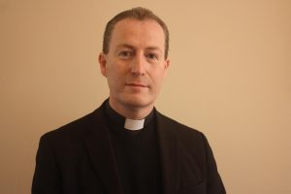

**'To Sing Is To Pray Twice' - Donna Taggart: Saturday 17 August at 8pm**

Donna Taggart is an Irish singer-songwriter. The greatest artists are able to express both the harsh realities of life, as well as the joy. Donna’s early career influenced her songwriting as she witnessed first-hand the darker side of life while working in a refuge centre for women and children affected by domestic violence. Donna also worked as a youth worker for young people at risk of homelessness and as a behavioural therapist to children with autism. Her caring nature and dedication to helping others, has shaped the artist she is today.

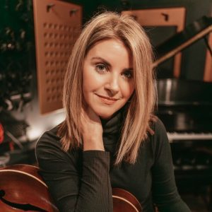

**'Praying the Mysteries of Creation' - Bishop Kevin Doran: Sunday 18th August at 3pm**